PR-202009B

ONCLICK

ONLINE SHOPPING MALL



Contents

TABLE OF CONTENTS 2

CERTIFICATE OF COMPLETION ……………………………………………………………………………………………………………..3

ACKNOWLEDGMENT………………………………………………………………………………………………………………………….4

PROJECT SYNOPSIS 5

PROBLEM STATEMENT 6

PROJECT ANALYSIS 7

CUSTOMER REQUIREMENTS ANALYSIS 8

PROJECT PLAN 9

DFD DIAGRAM 10

TASK SHEET 11

E-R DIAGRAM…………………………………………………………………………………………………………………………………….12

ALGORITHMS 13

UNIT TESTING CHECKLIST 14

FINAL CHECKLIST  15

ALGORITHMS  16

GUI STANDARD DOCUMENT  17

3

CERTIFICATE OF COMPLETION  


#### This is to certify that

#### **SABA**

#### **ASMA**

#### **SUMAIRA**

**Has successfully design and developed**

ONLINE SHOPPING MALL

**Supervised by:**

**MIS TAHIRA**

**E-Project DISM**

APTECH World Wide Education

Shahrah-e-Faisal Centre, Karachi

Received By:

ACKNOWLEDGMENT

4

Acknowledgment is not a mere formality but a genuine opportunity to thank all those people, whose active support made this project possible. We are thankful to Almighty Allah with his grace. The project that we are successfully presenting on “ONLINE SHOPPING”. This project has been developed with the help of C (sharp) /SQL / MVC. I would like to acknowledge all those who have given moral support and helped me to make this project a success. I wish to express my gratitude to MISS TAHIRA for his valued guidance and support for the completion of this project.

And finally, I would like to offer many thanks to all my colleagues for their valuable suggestions and constructive feedback.



5

PROJECT SYNOPSIS



PROJECT SYNOPSIS

6

Background:

Online shopping or e-shopping is a form of electronic commerce which allows consumers to directly buy goods or services from a seller over the Internet using a web browser. Alternative names are: e-web-store, e-shop, e-store, Internet shop, web-shop, web-store, online store, online storefront and virtual store. Mobile commerce (or m-commerce) describes purchasing from an online retailer's mobile optimized online site or app.

Problem Statement:

Problem statement is attached separately in a file “**Online Shopping Cart**”

Every code block must have comments. The logic of the program needs to be explained. Proper documentation should be maintained. Complete Project Report along with synopsis, code and documentation should be prepared. No project is complete without documentation. In fact, it is one of the most important activities during the development of a project. The documentation of an ideal project will be in the form of a project report.

Project Analysis

7

Customer Requirements Analysis:

For the customers who have placed an order for which the payment type is either through cheque or through credit card, only after the clearance of the payment the products will be dispatched. If the order placed is through VPP, the customer is needed to make the payment at the time of delivery at their premises. If the customer is not satisfied with the product then he can either place a request for replacing the product or he can return the product, so that he/she can get the payment back, provided the product is returned with in the week days and time from the time of the delivery of the product at the customer premises.

**Hardware/ Software Requirements**

**Hardware**

* A minimum computer system that will help you access all the tools in the courses is a Pentium 166 or better

**Operating System**

* Windows 2000 Server (or higher if possible)

**Software**

* Notepad/Java editor
* j2sdk1.4.1_02 (or later) / .Net / J2EE
* JSP / Servlets
* EJB / Struts
* JDBC
* SQL Server 2000 (or later) / Oracle 9i / MS Access
* JDBC Driver

8

PROJECT PLAN

|  |  |  |  |
| --- | --- | --- | --- |
|  | **ASMA** | **SUMAIRA** | **SABA** |
| **C (SHARP)** | **YES** | **YES** | **YES** |
| **SQL** | **YES** | **YES** | **YES** |
| **MVC** | **YES** | **YES** | **YES** |
| **E Project Requirements** | **YES** | **YES** | **YES** |
| **Documentation** | **YES** | **YES** | **YES** |



9

DFD DIAGRAM

To

Online shopping

Customer

Category

has

Does

Payment

Done

Cart

Made

Cart item

Add to

Products

Has

To

TASK SHEET

10

11

|  |  |  |  |  |  |  |
| --- | --- | --- | --- | --- | --- | --- |
| Project Ref. No.: eP/advertisement Portal Management System/01 | | Project Title | Date of Preparation of Activity Plan | | | |
| No | Task | Online  Shopping  Mall | Actual Start Date | Actual Days | Team-mate Names | Status |
| 1 | Home Page | DD/MM/YY | 2 | Asma | Complete |
| 2 | Shop | DD/MM/YY | 1 | Asma | Complete |
| 3 | Checkout, Confirmation | DD/MM/YY | 2 | Asma | Complete |
| 4 | Order, Address,  Profile Details | DD/MM/YY | 3 | Asma | Complete |
| 5 | Cart | DD/MM/YY | 2 | Saba | Complete |
| 6 | Pricing | DD/MM/YY | 1 | Saba | Complete |
| 7 | Dashboard | DD/MM/YY | 3 | Saba | Complete |
| 8 | Faq | DD/MM/YY | 2 | Saba | Complete |
| 9 | Product Details | DD/MM/YY | 3 | Sumera | Complete |
| 10 | Login, Sign | DD/MM/YY | 2 | Sumera | Complete |
| 11 | Contact us,  About us,  404 Page,  Coming soon | DD/MM/YY | 1 | Sumera | Complete |
| 12 | Documentation | DD/MM/YY | 2 | Sumera | Complete |

PROJECT REVIEW AND MONITING REPORT

11

|  |  |  |  |  |
| --- | --- | --- | --- | --- |
| E-Project Report | | | | |
| Student Details | Name | Asma | Saba | Sumera |
| Enrolment No | 12 | 13 | 14 |
| Semester | DISM | DISM | DISM |
| E-Project Details | E-Project Tittle | Online Shopping Mall | | |
| Duration Project | 25 days | | |
| Start Date | 20-oct-2021 | | |
| End Date | 12-nov-2021 | | |
| Project Status / Mentoring | 1st Status | 1-nov-2021 | | |
| Sent Date | 1-nov-2021 | | |
| Snapshot | yes | | |
| Remarks | Good | | |
| 2nd and Final Status | 10-nov-2021 | | |
| Sent Date | 10-nov-2021 | | |
| Snapshot | yes | | |
| Remarks | Excellent | | |
| Student Comment | How our (e-projects team) suggestion helped you | Good | | |
| Feedback / Remarks | Great | | |

E-R DIAGRAMS

12

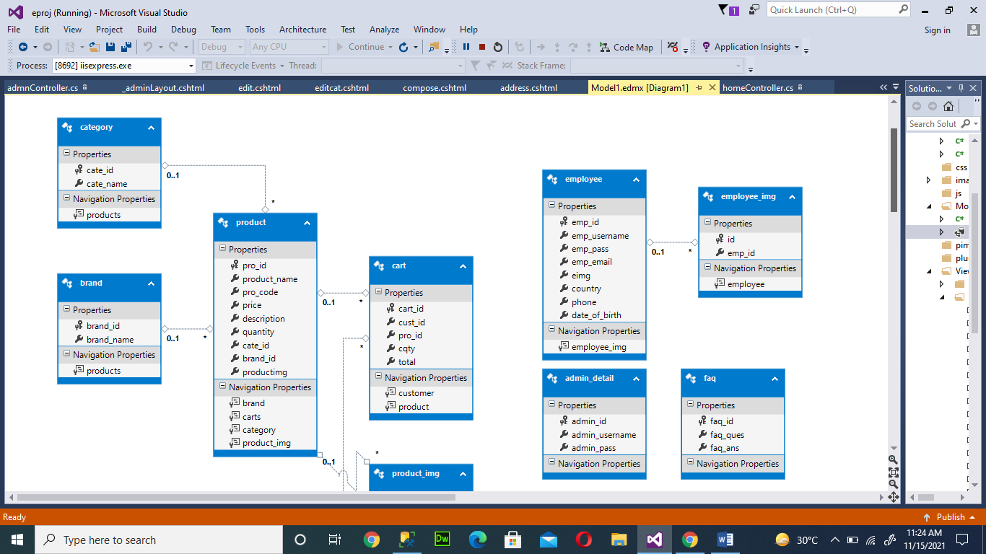

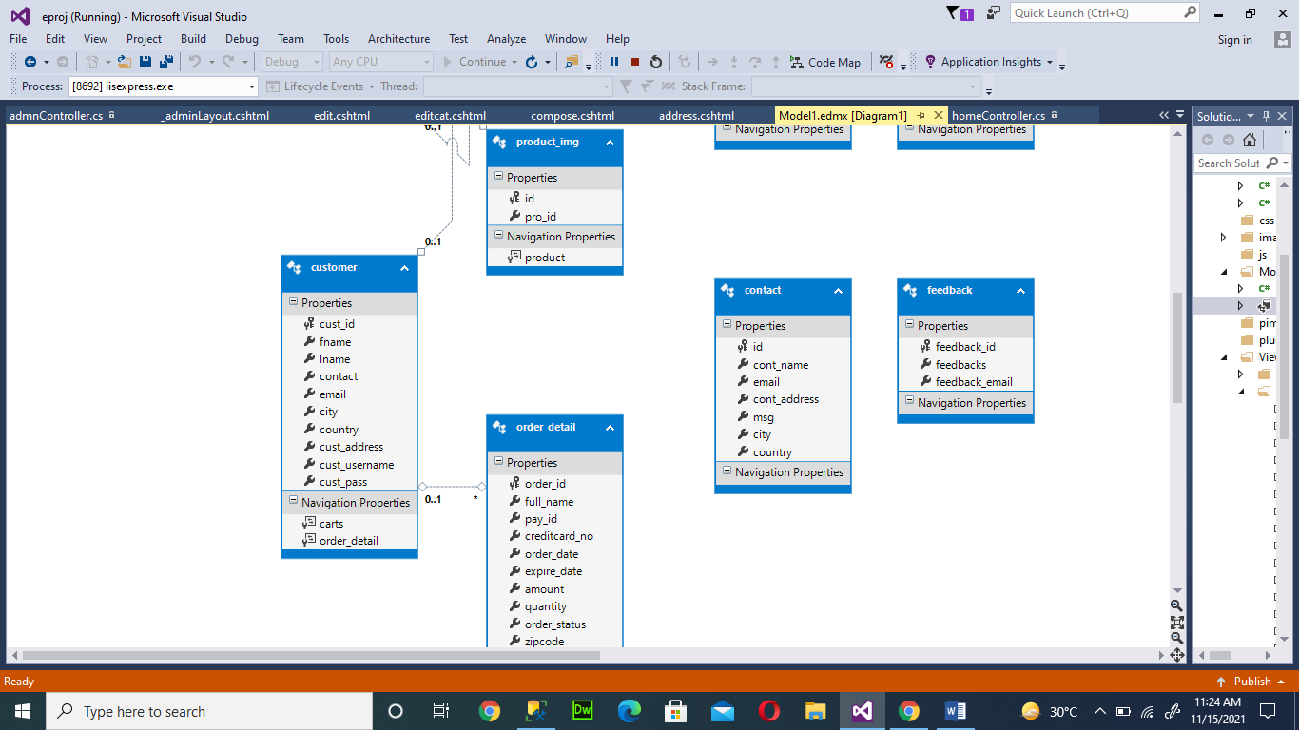

ALGORITHMS

13

HOME CONTROLLER:

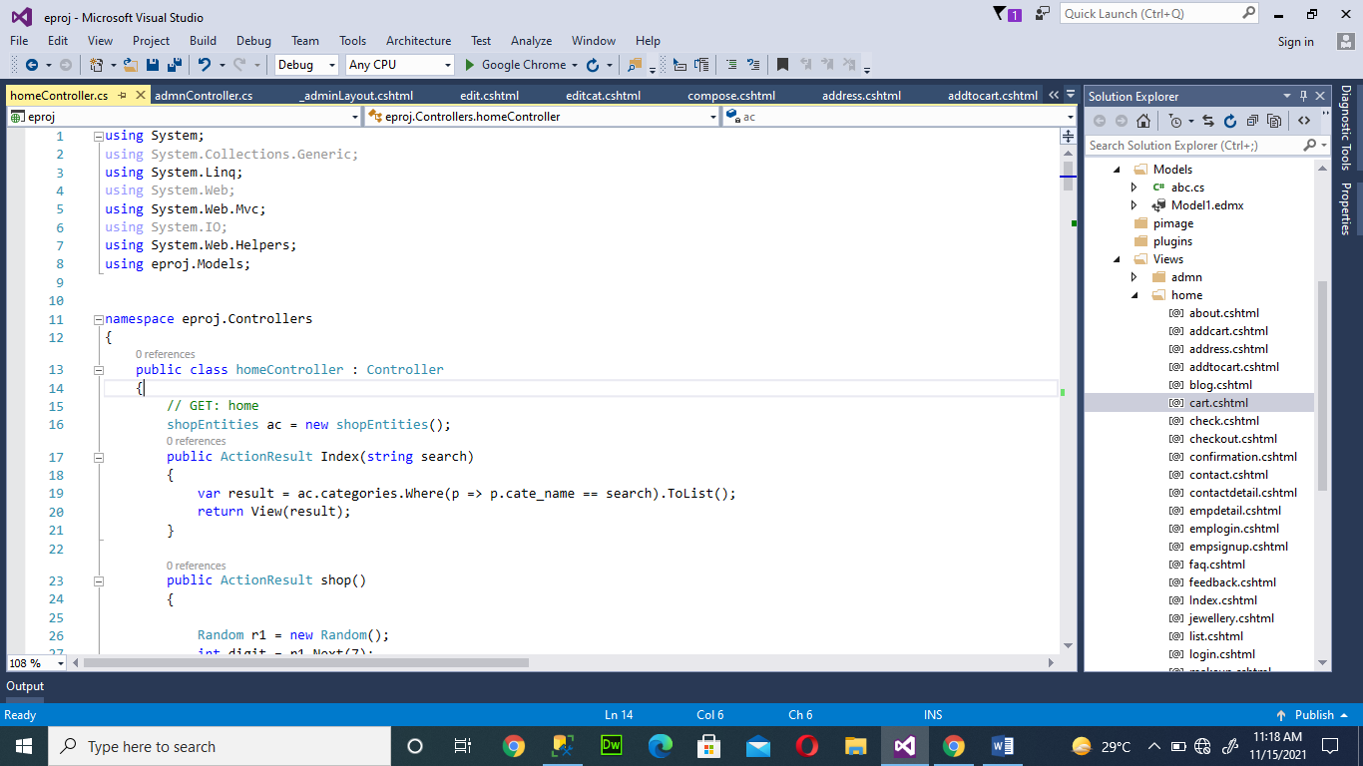

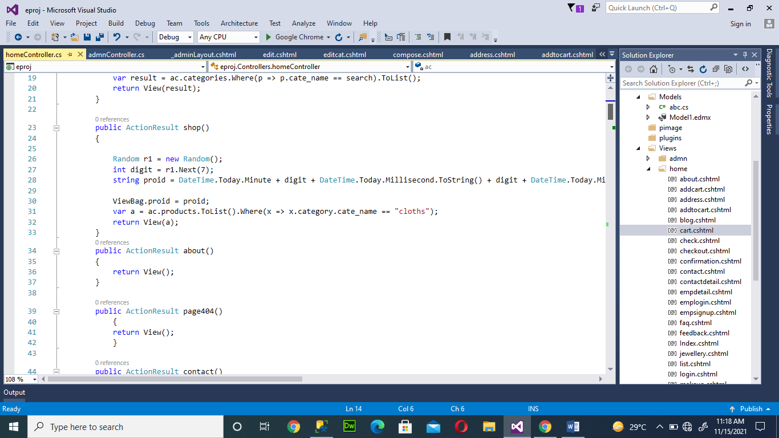

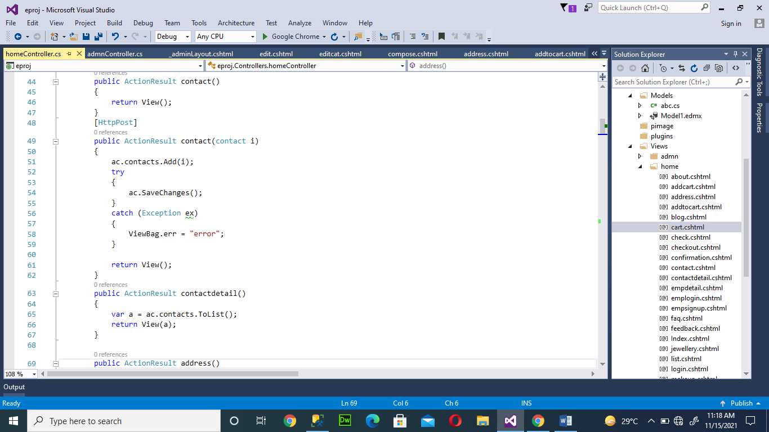

14

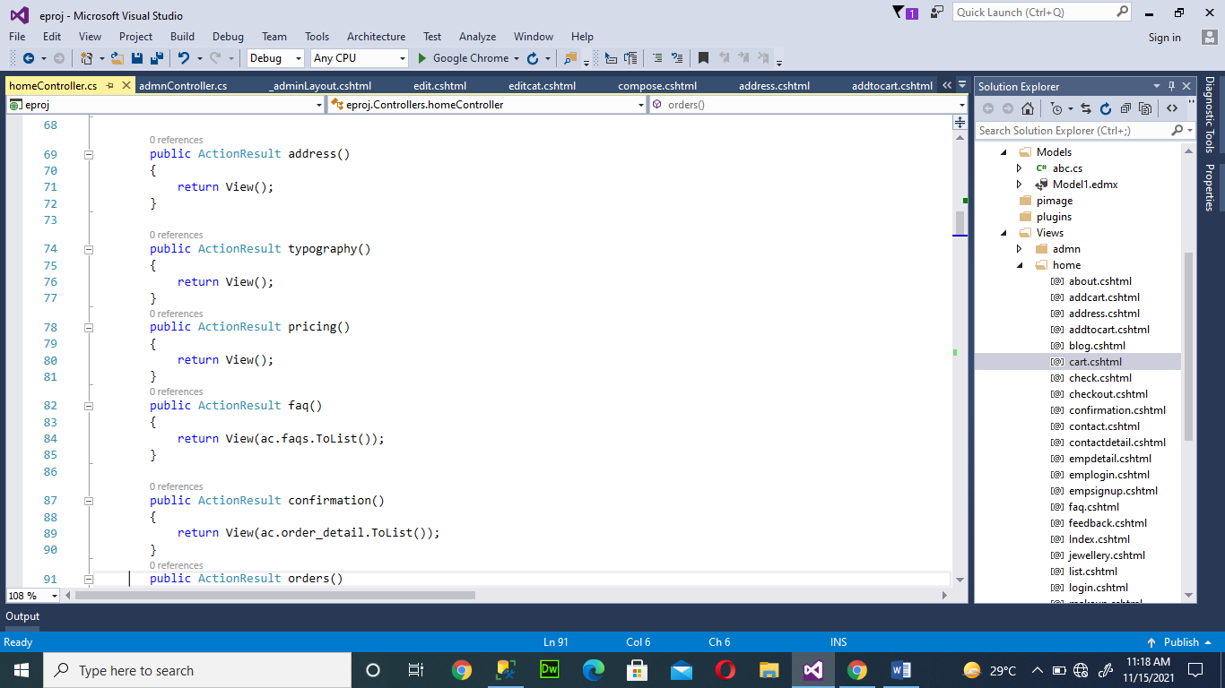

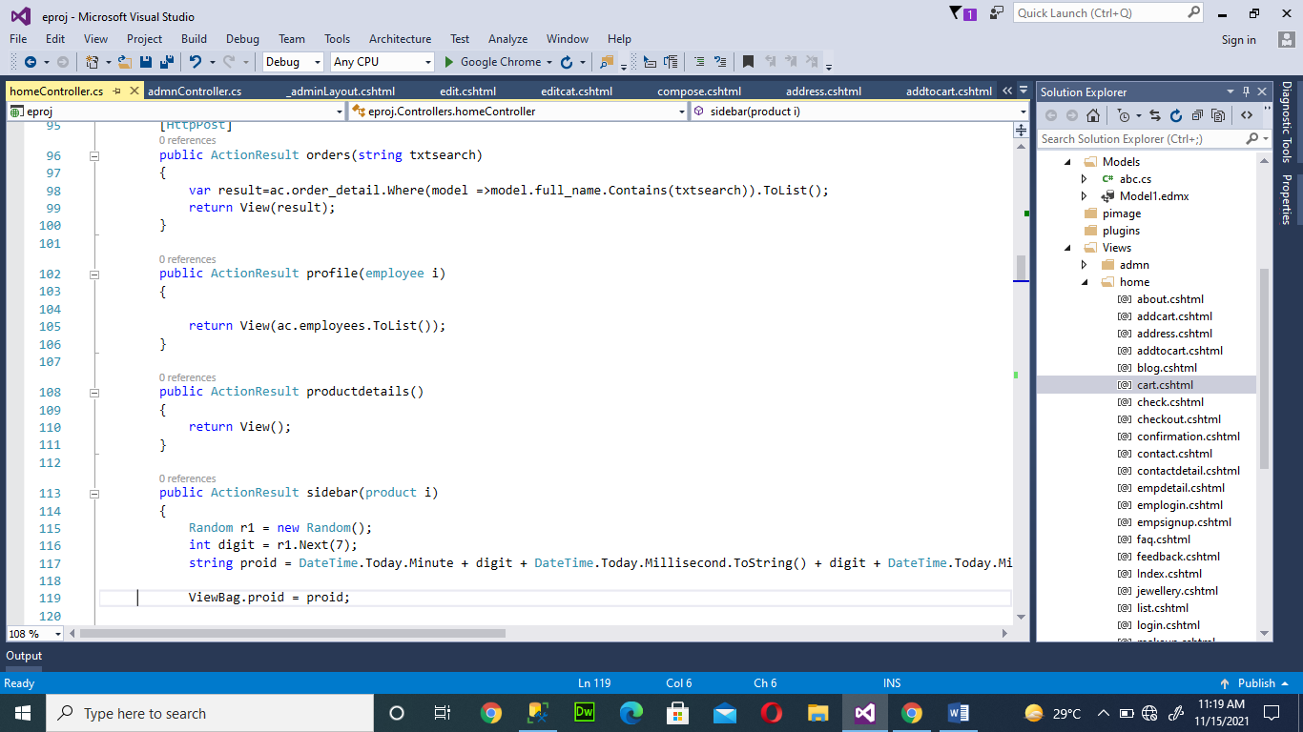

15

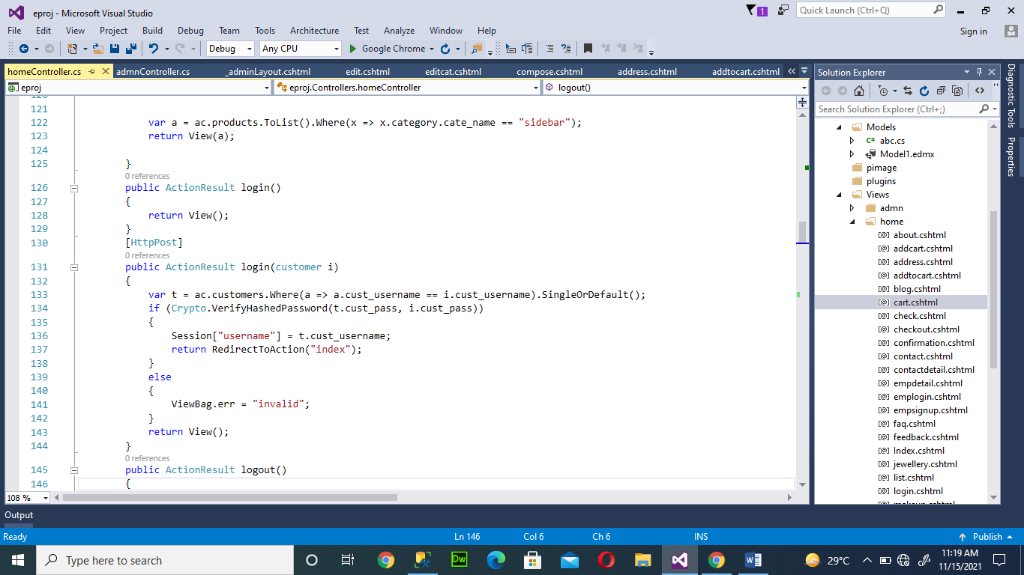

ADMIN CONTROLLER: 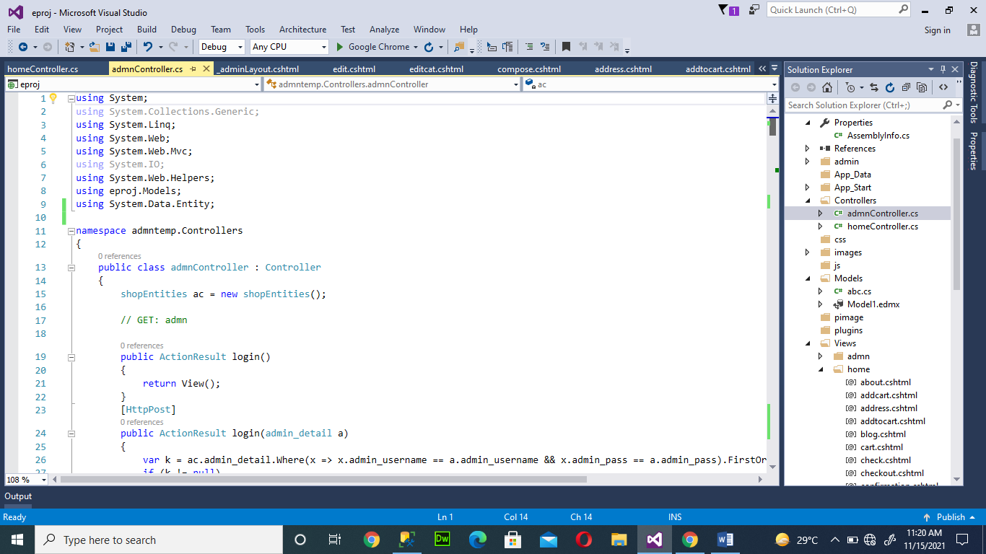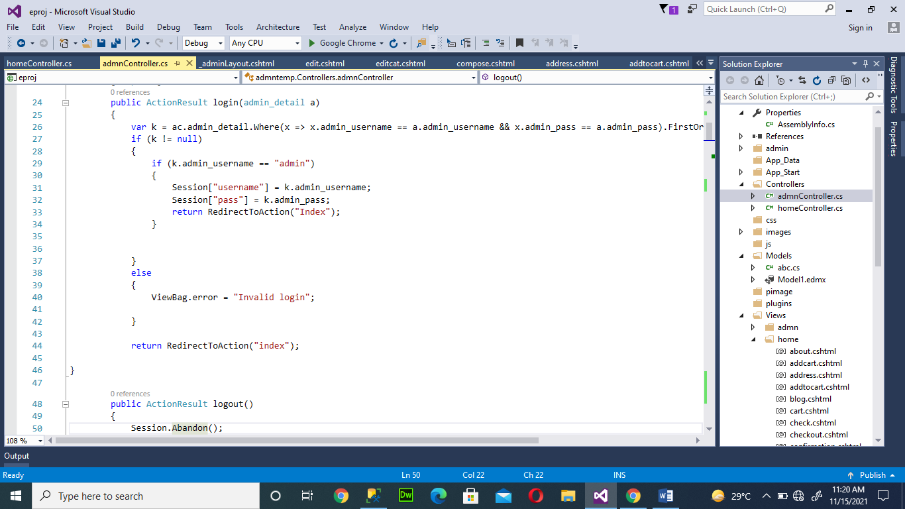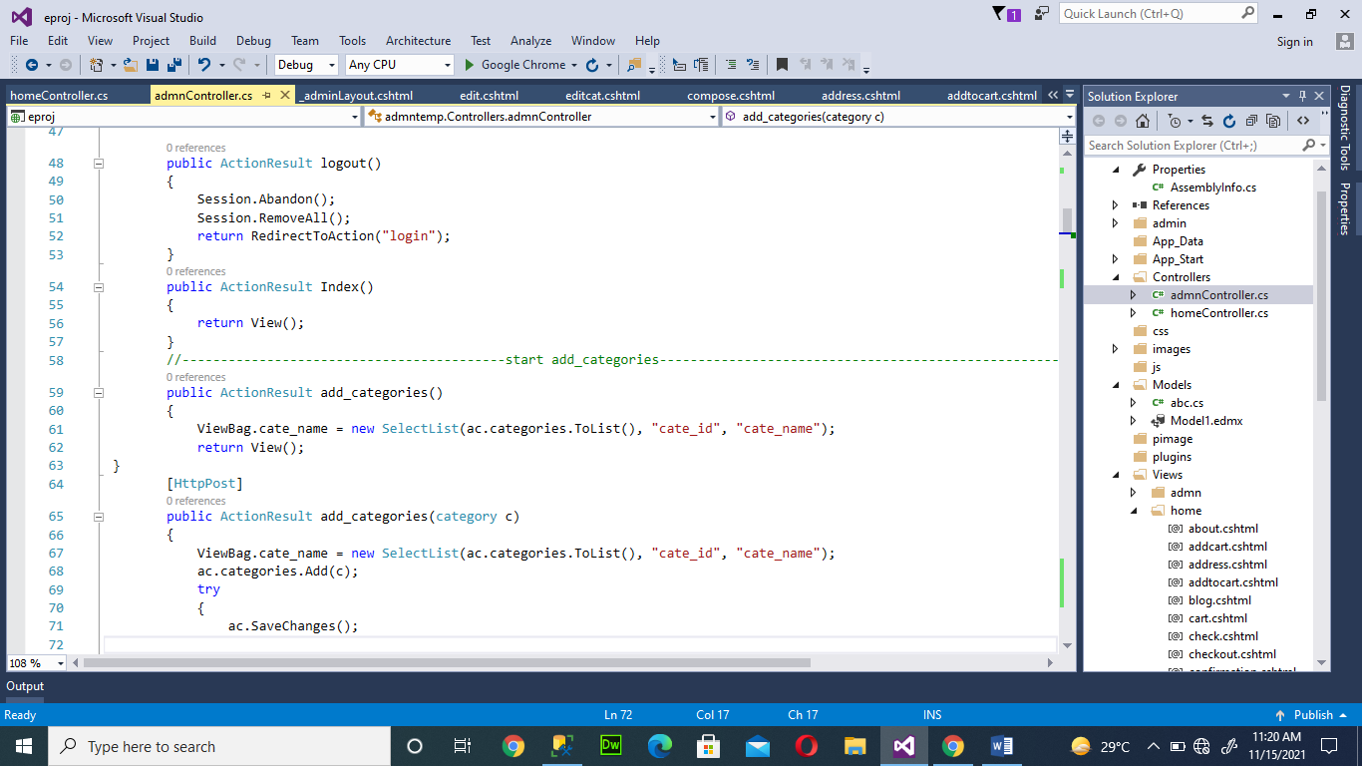 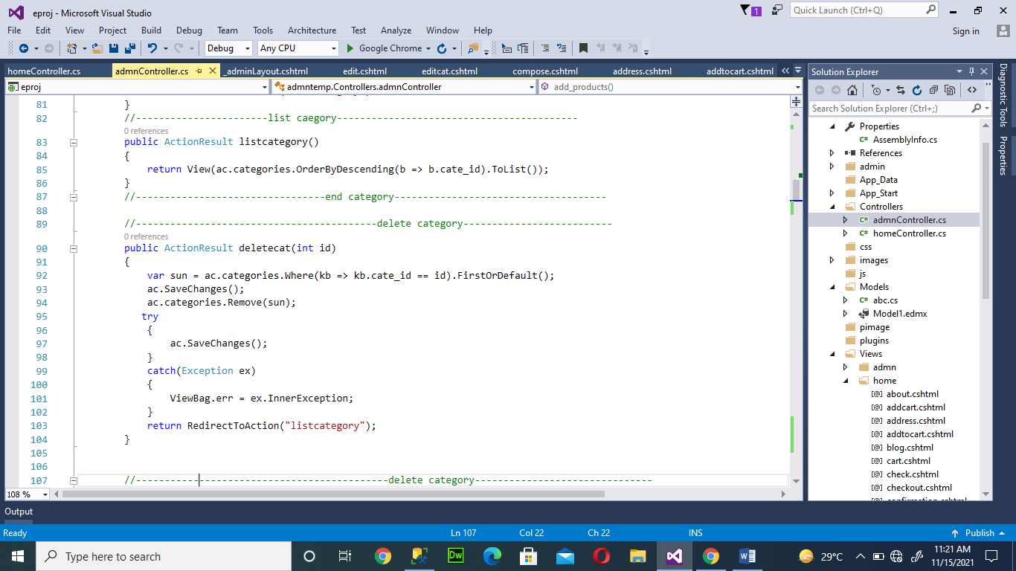

16

17

Home View

18

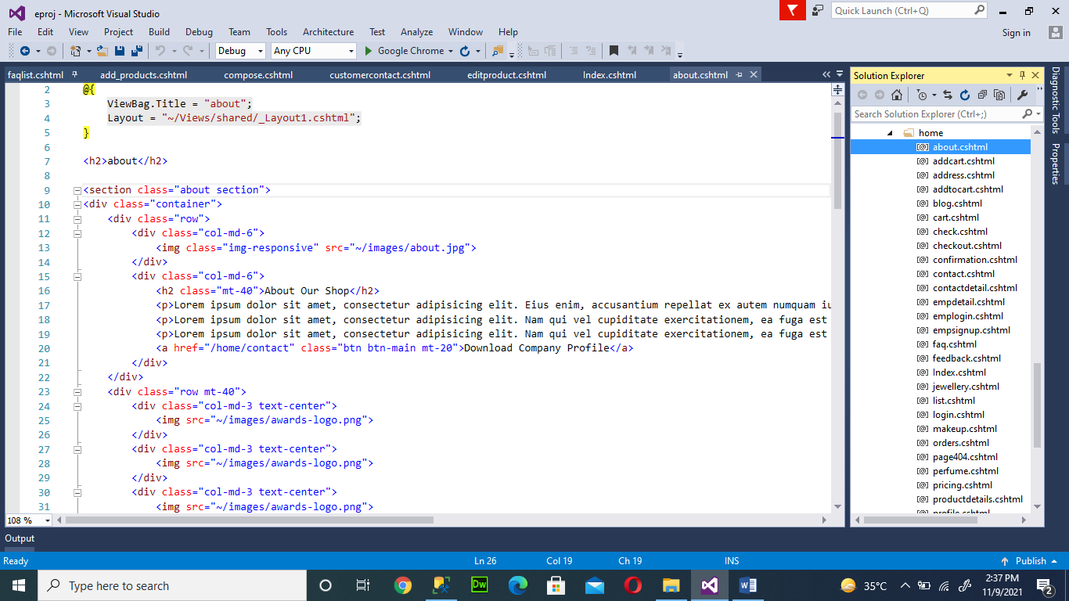

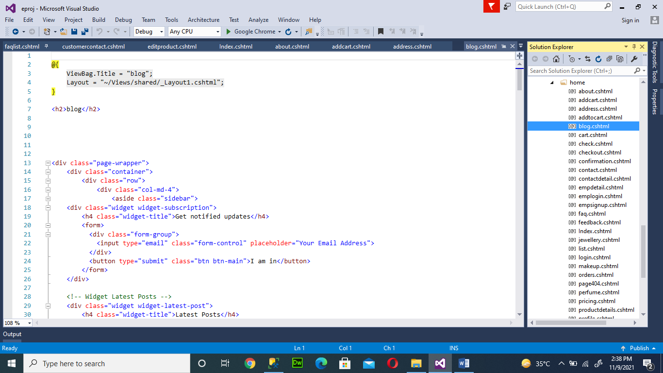

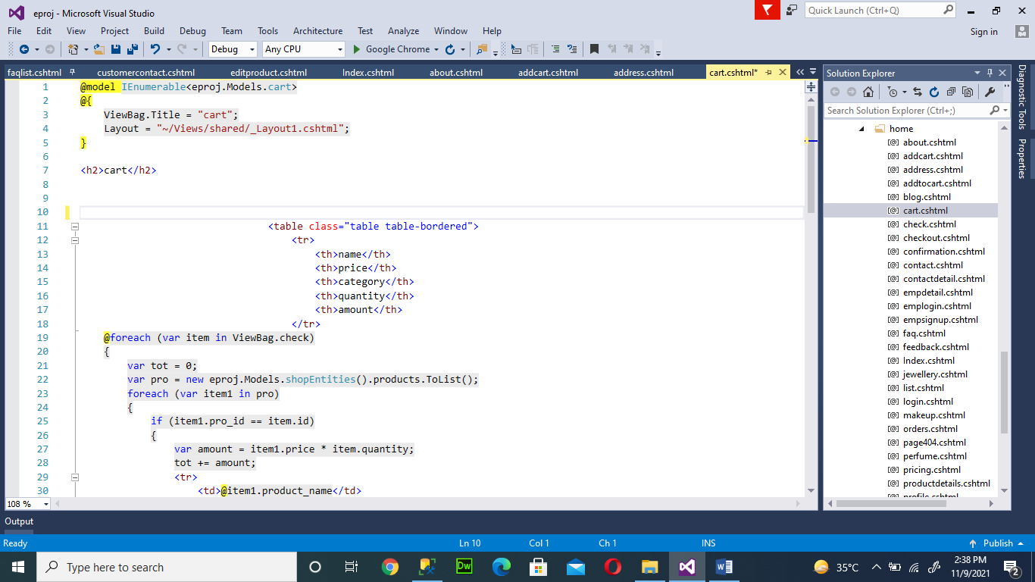

19

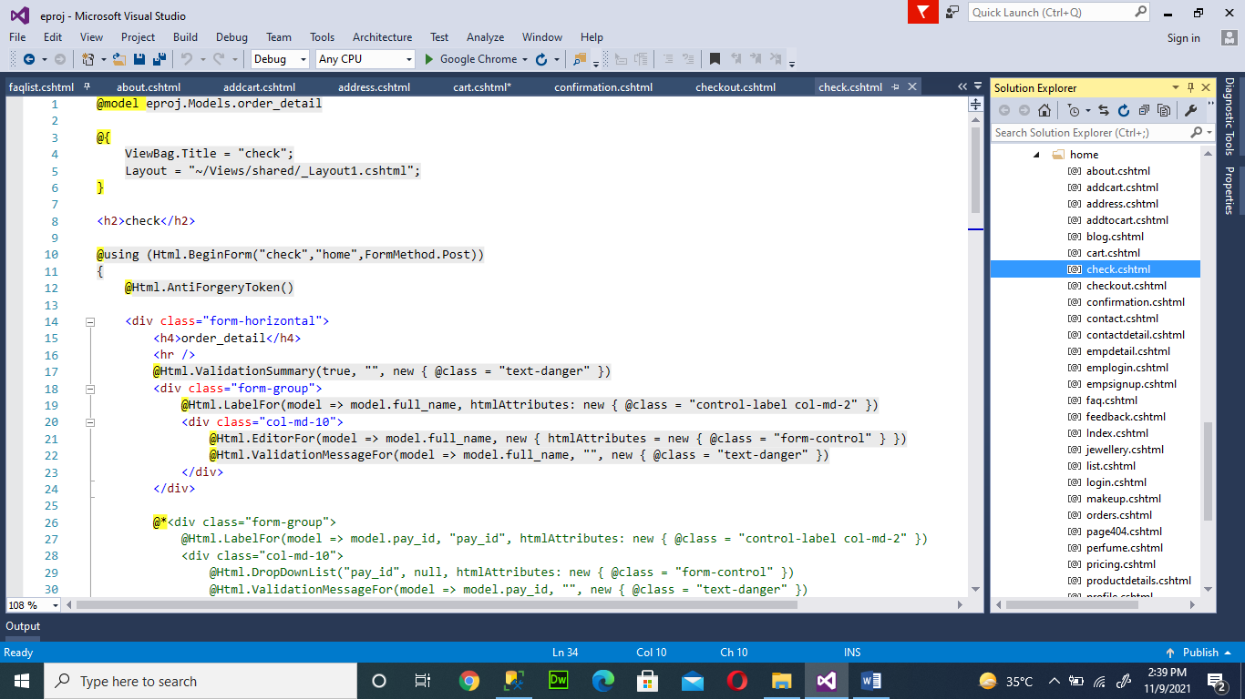

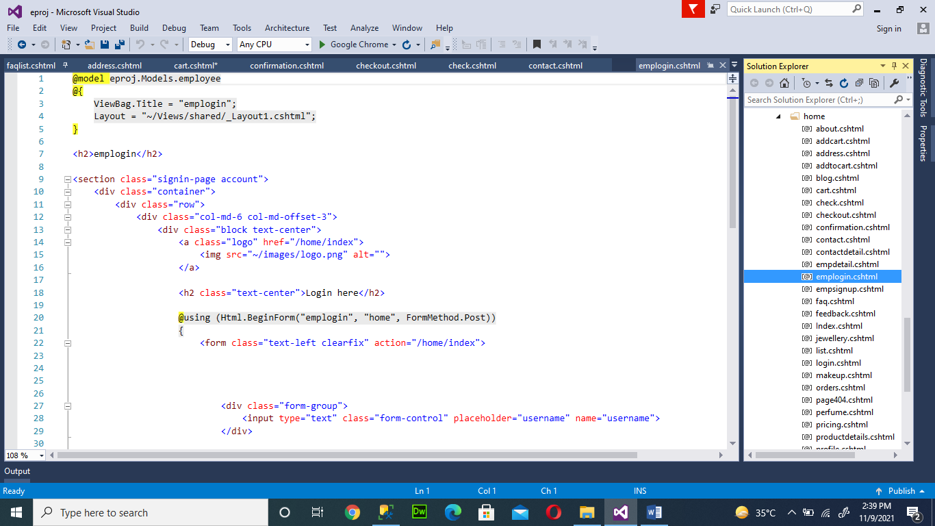

20

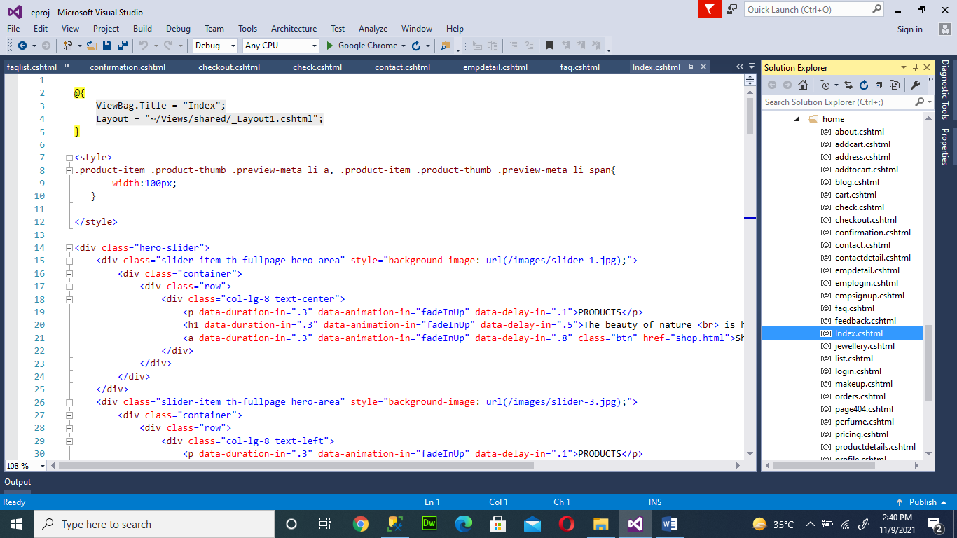

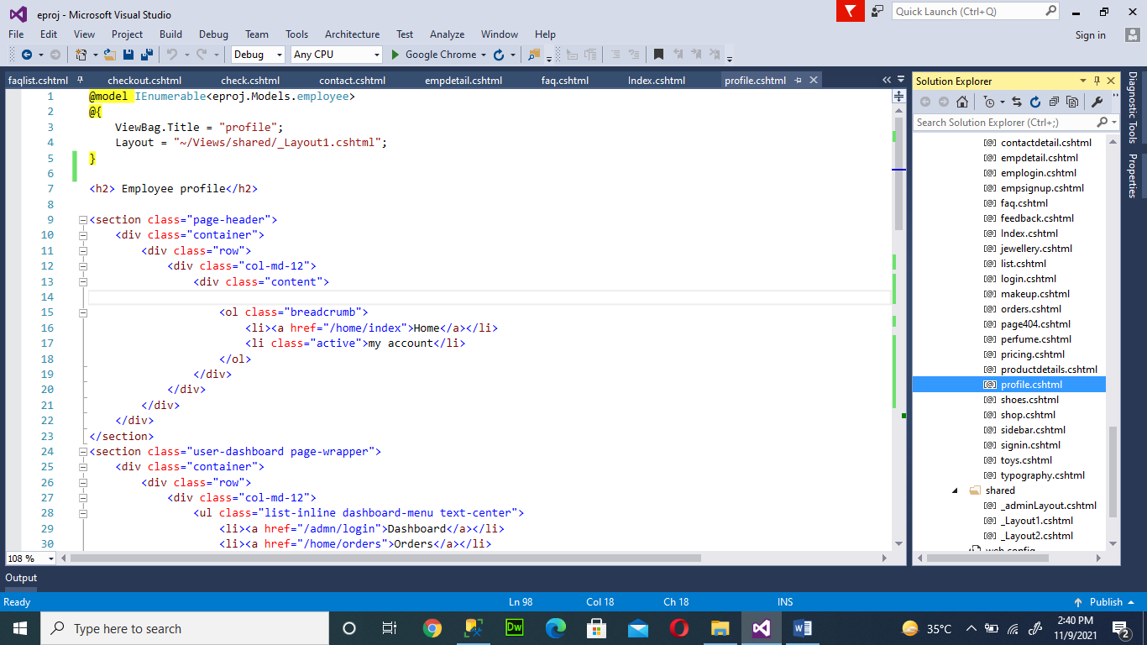

21

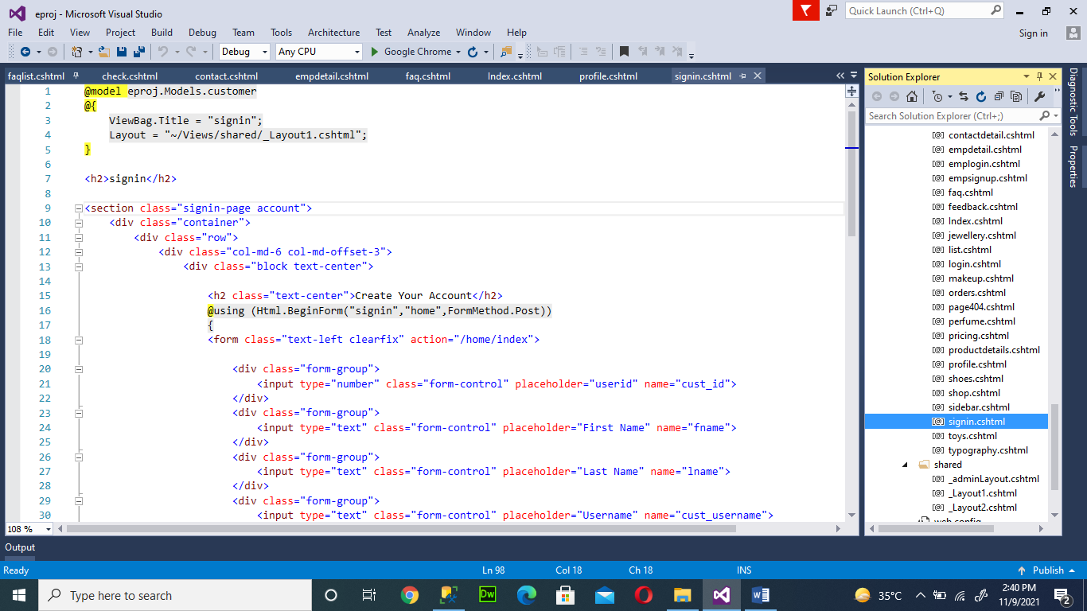

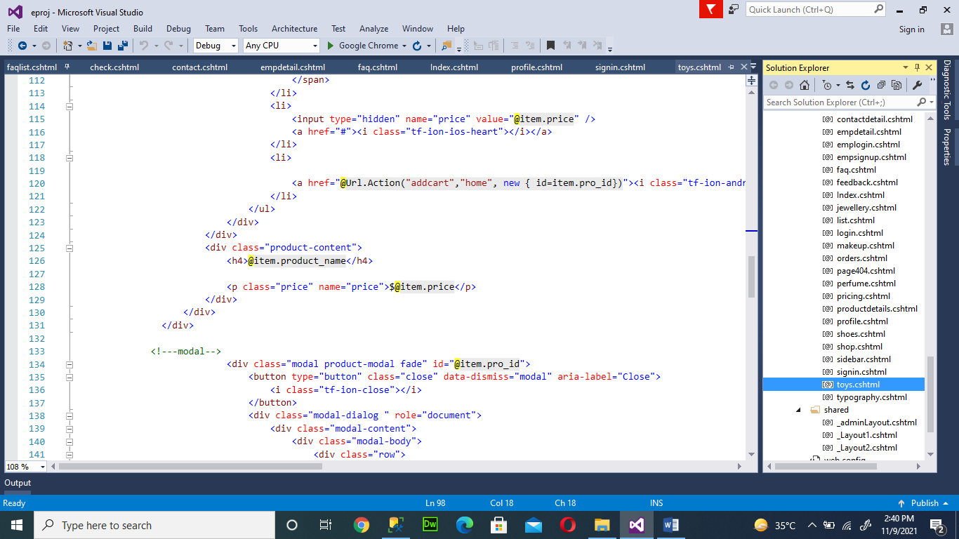

22

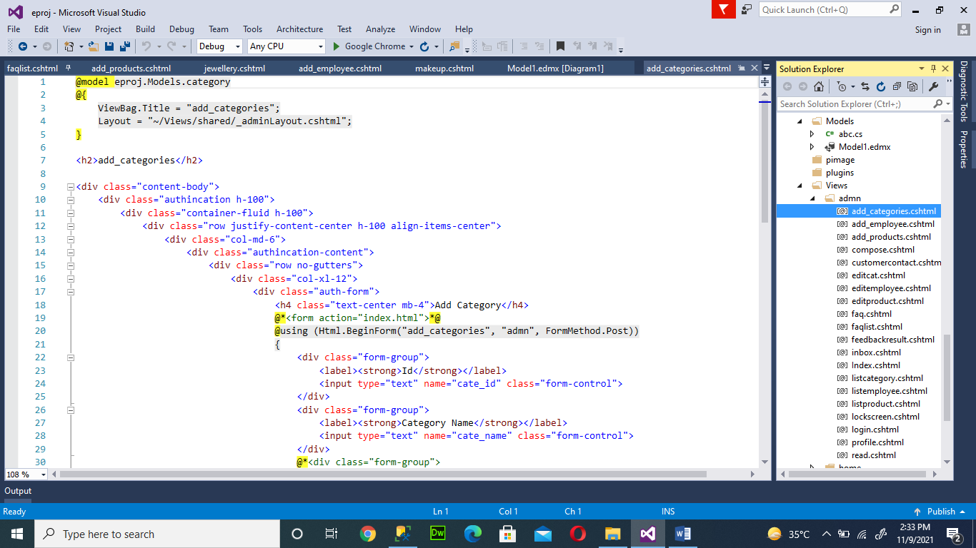Admin view

24

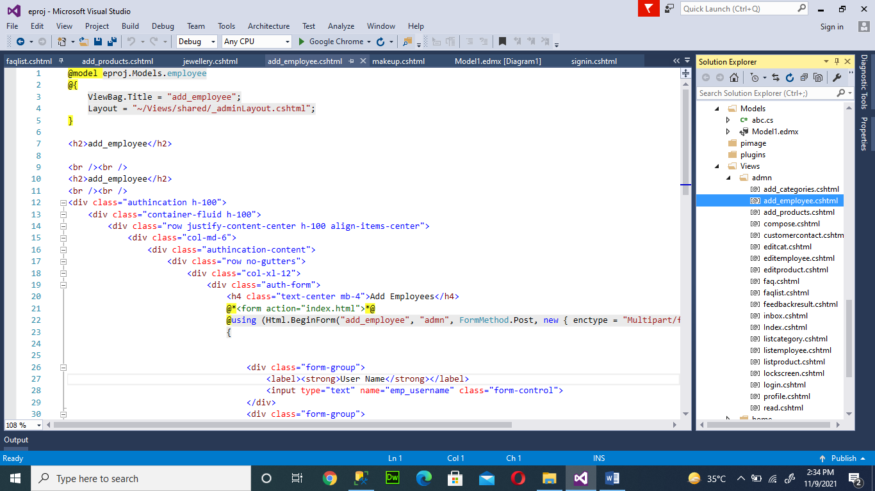

23

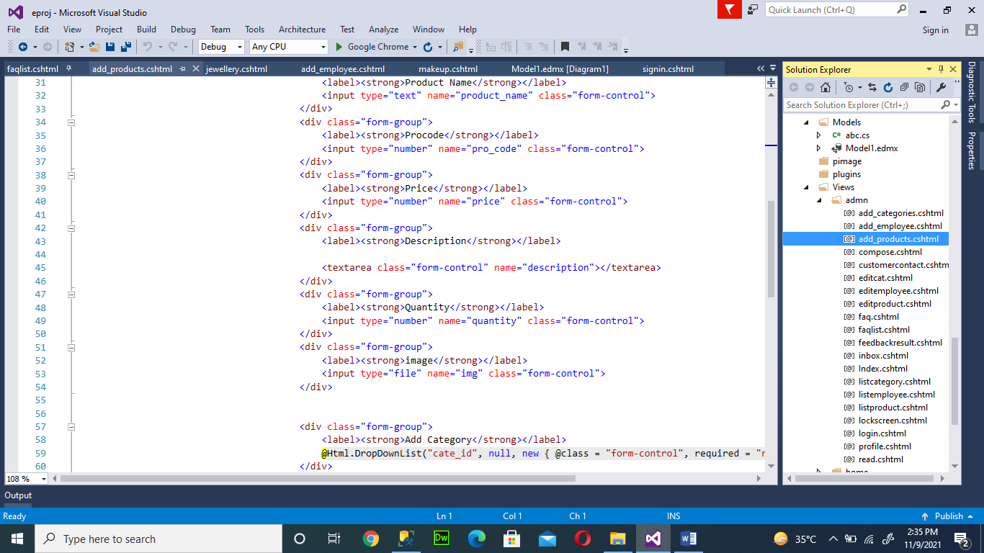

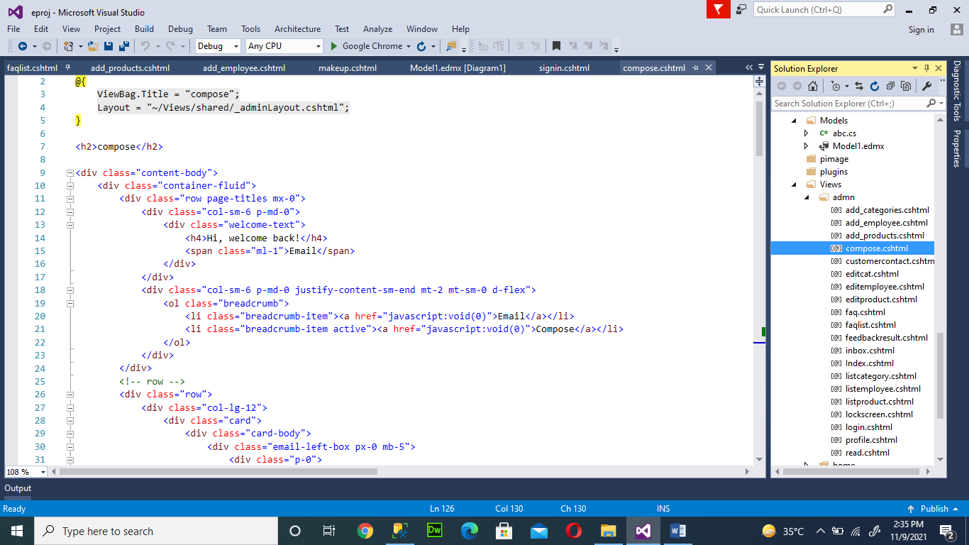

24

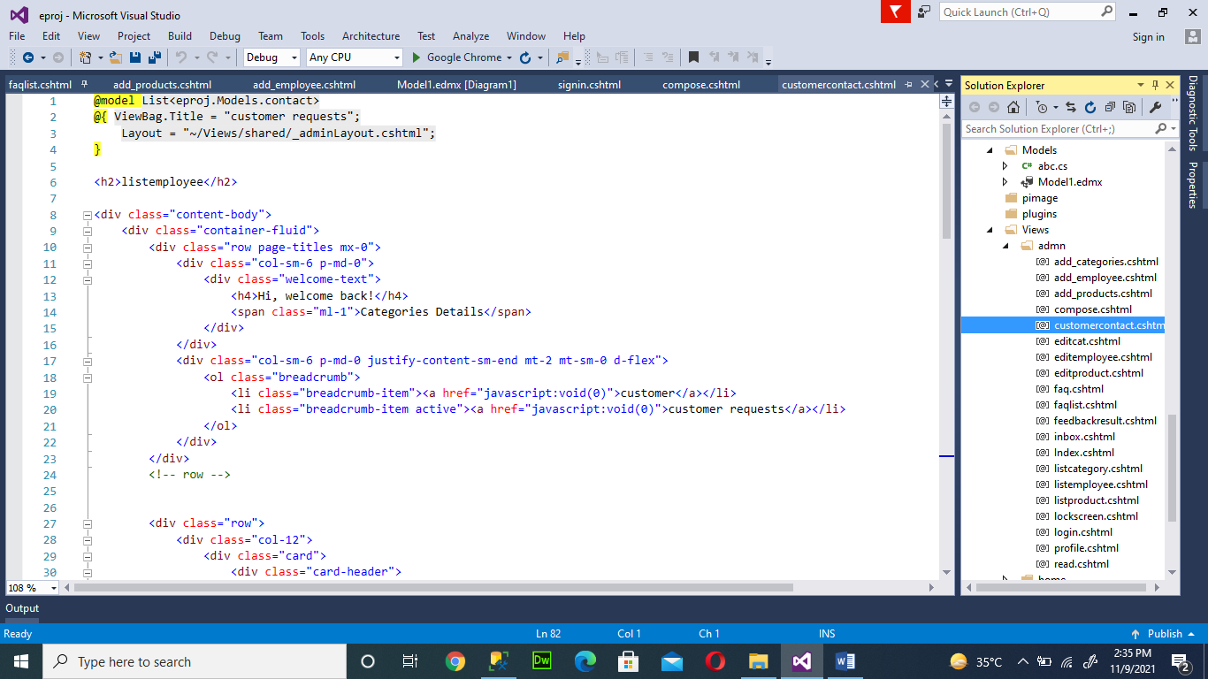

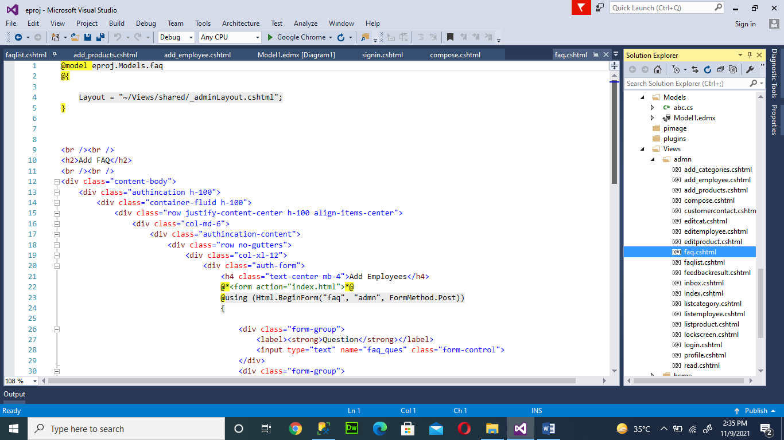

25

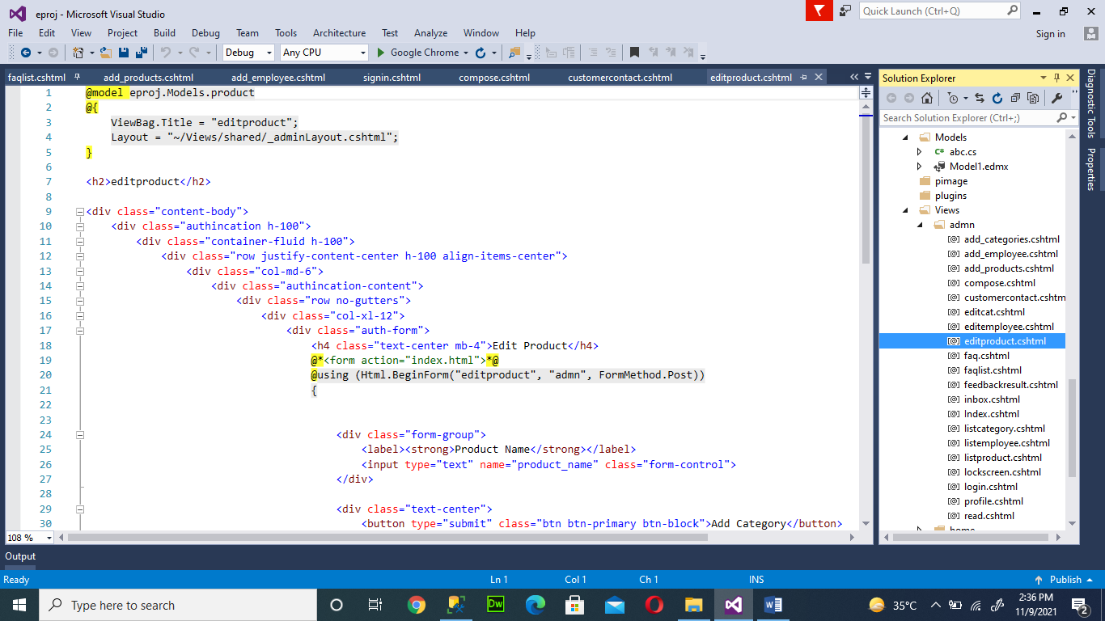

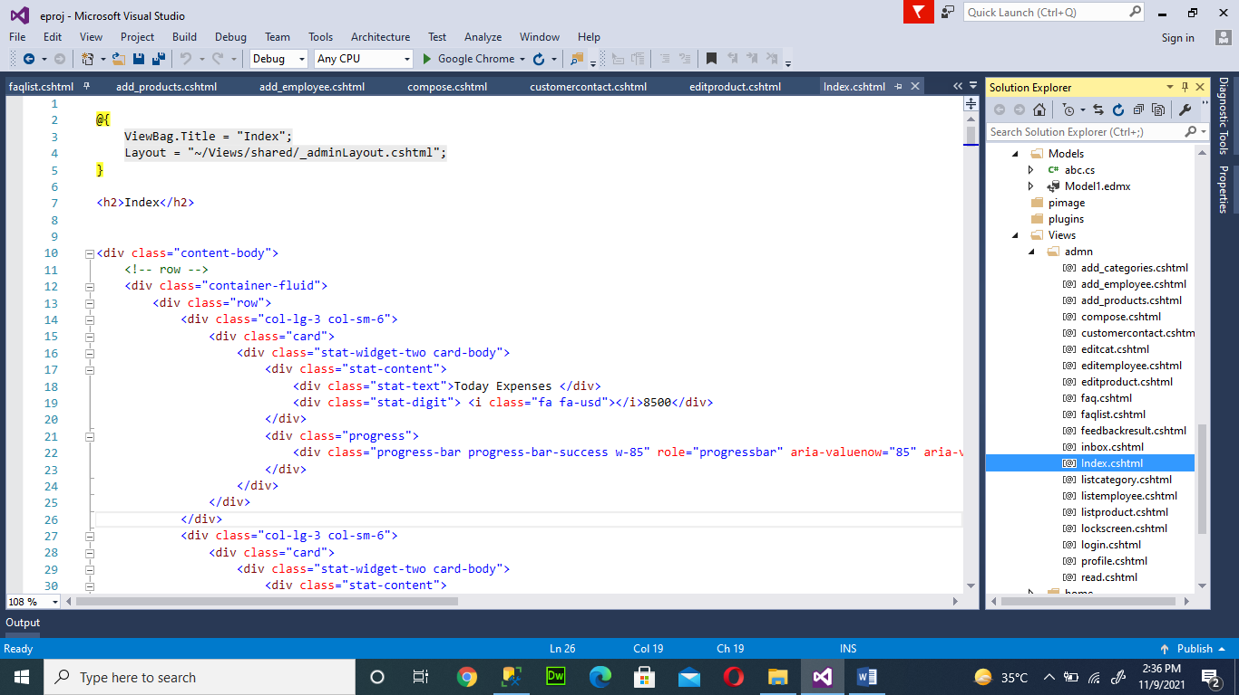

26

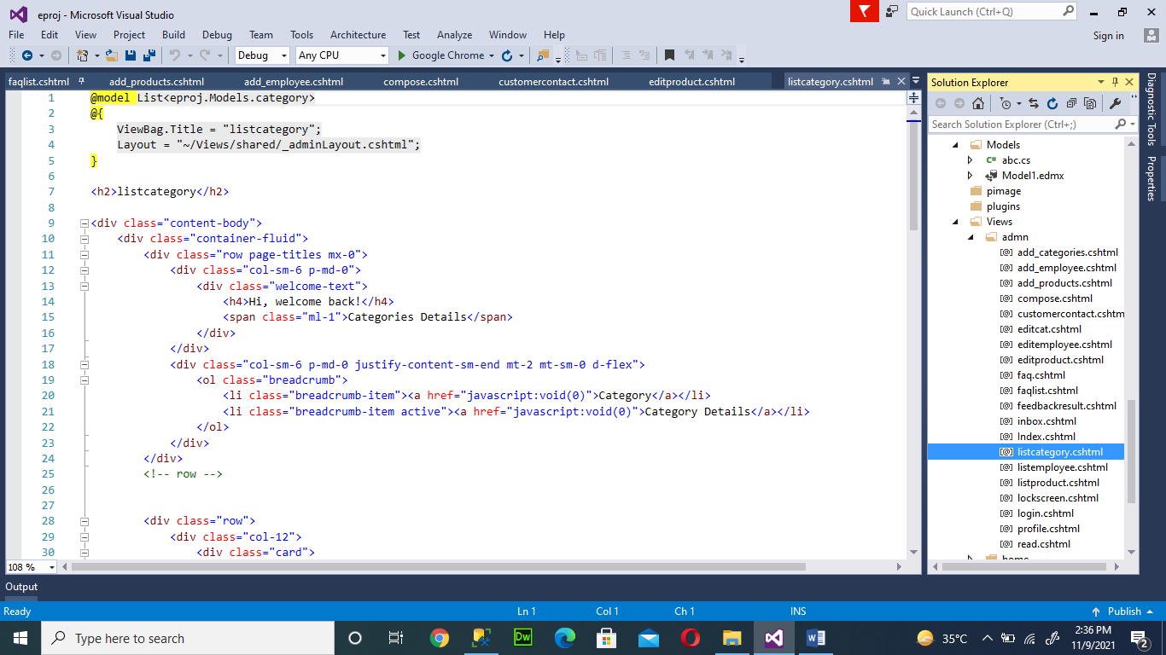

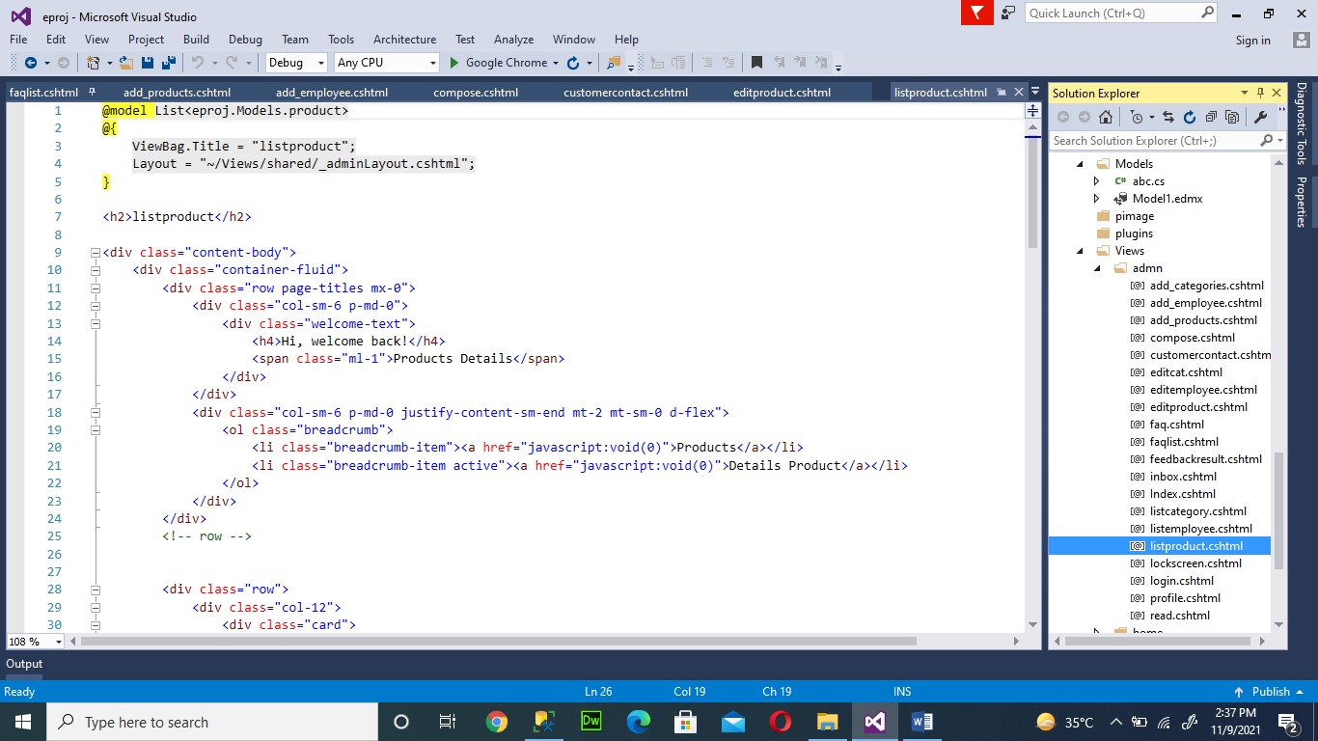

27

GUI STANDARAD DOCUMENT

28

Home Page



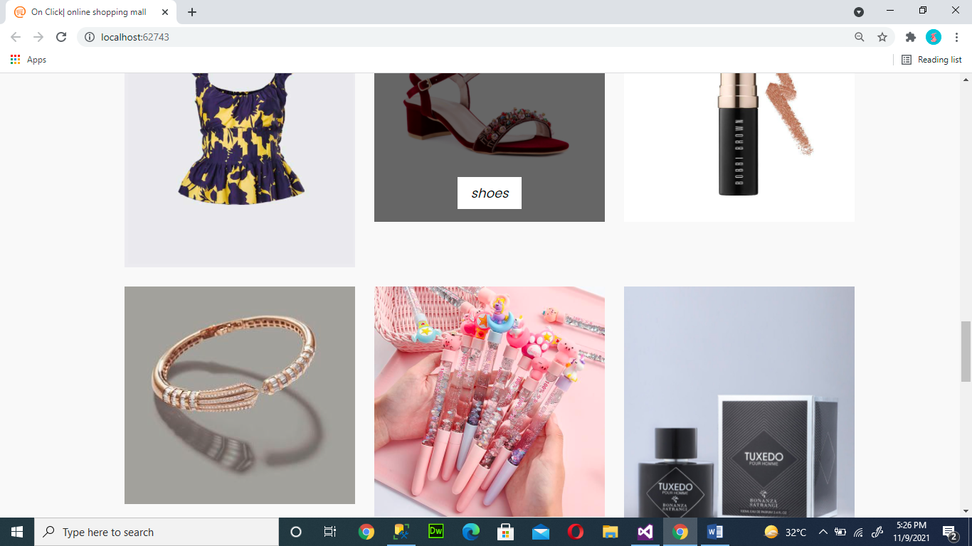

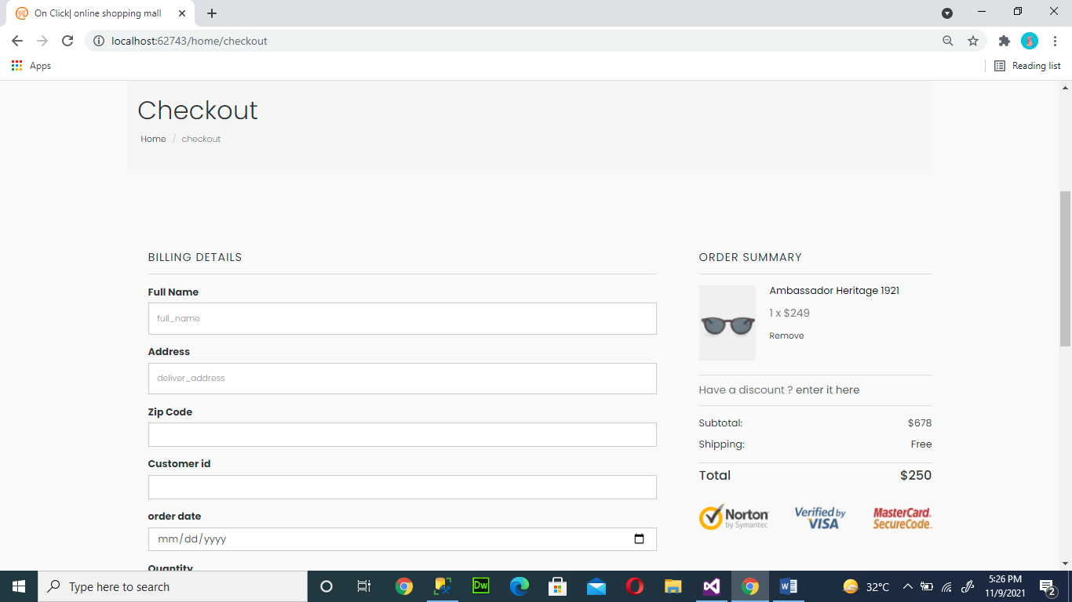

29

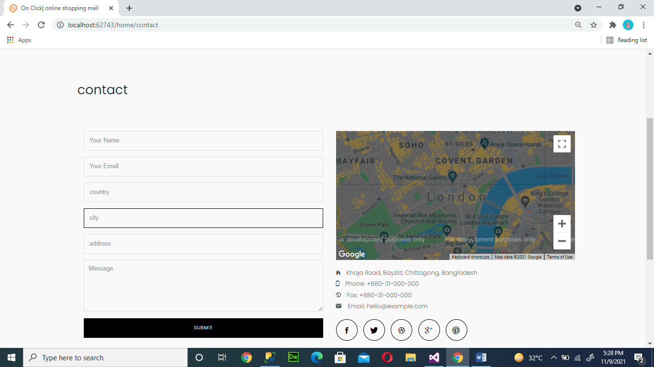

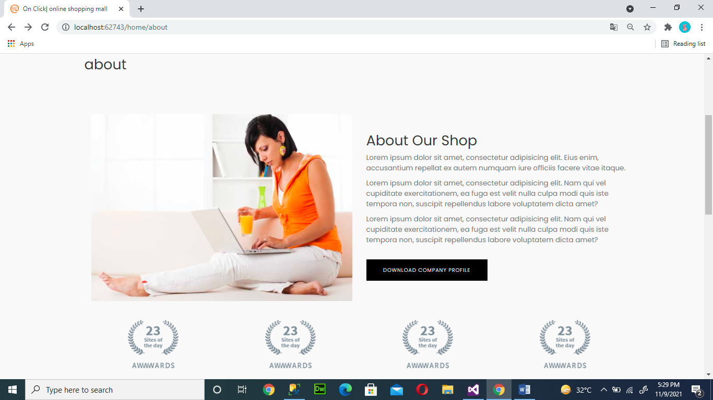

30

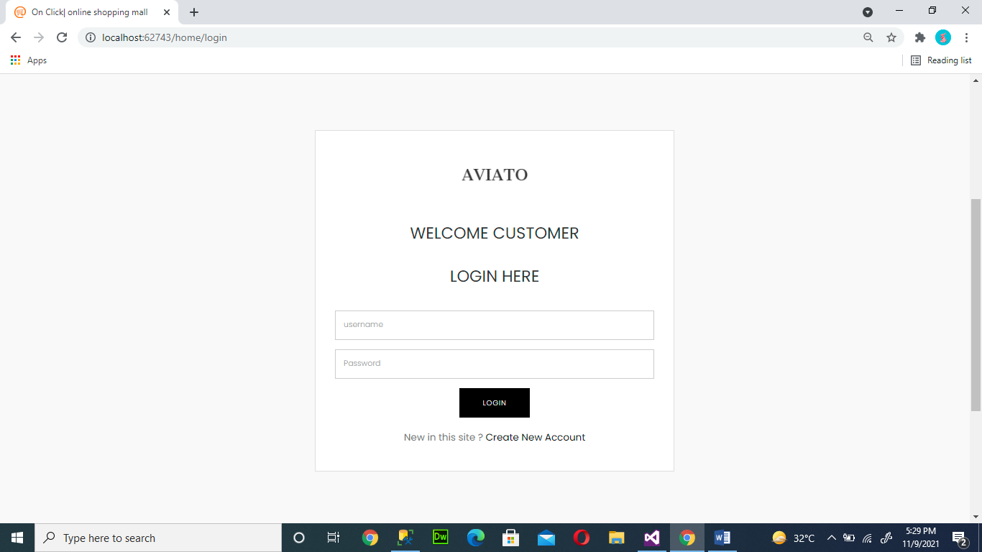

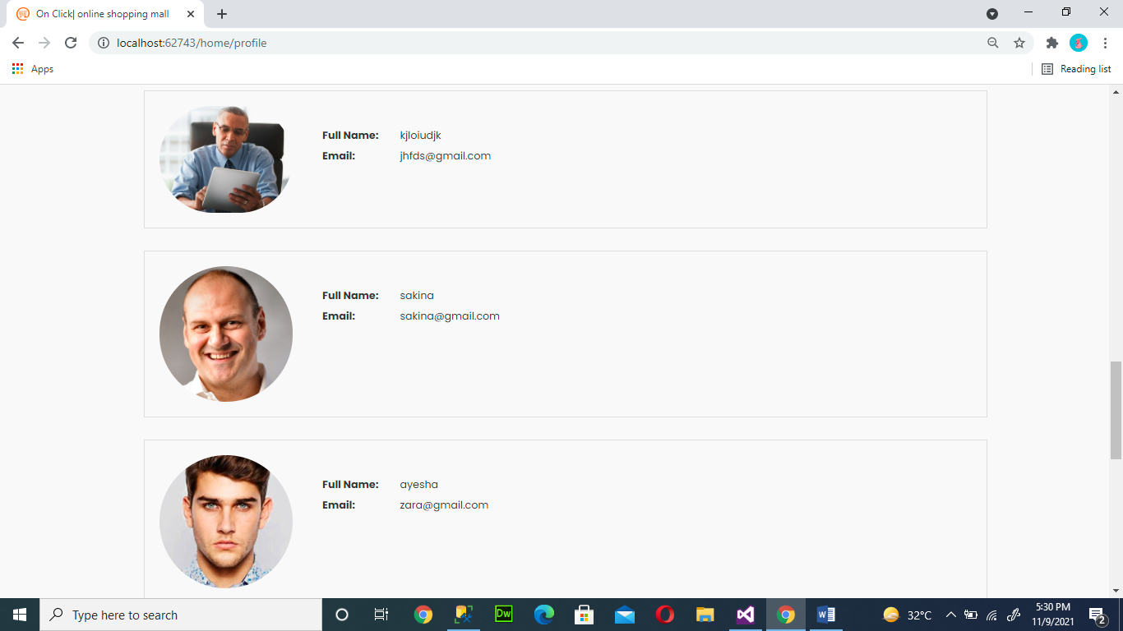

31

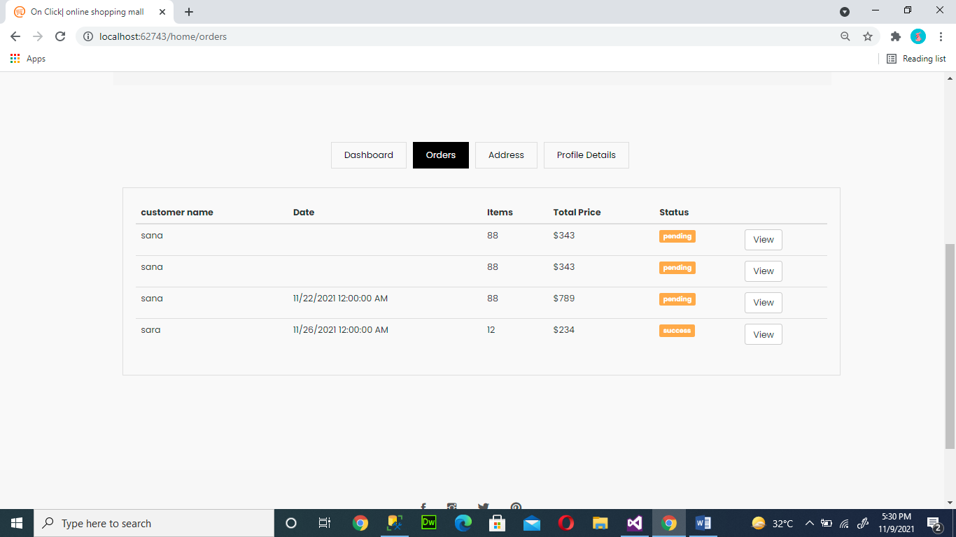

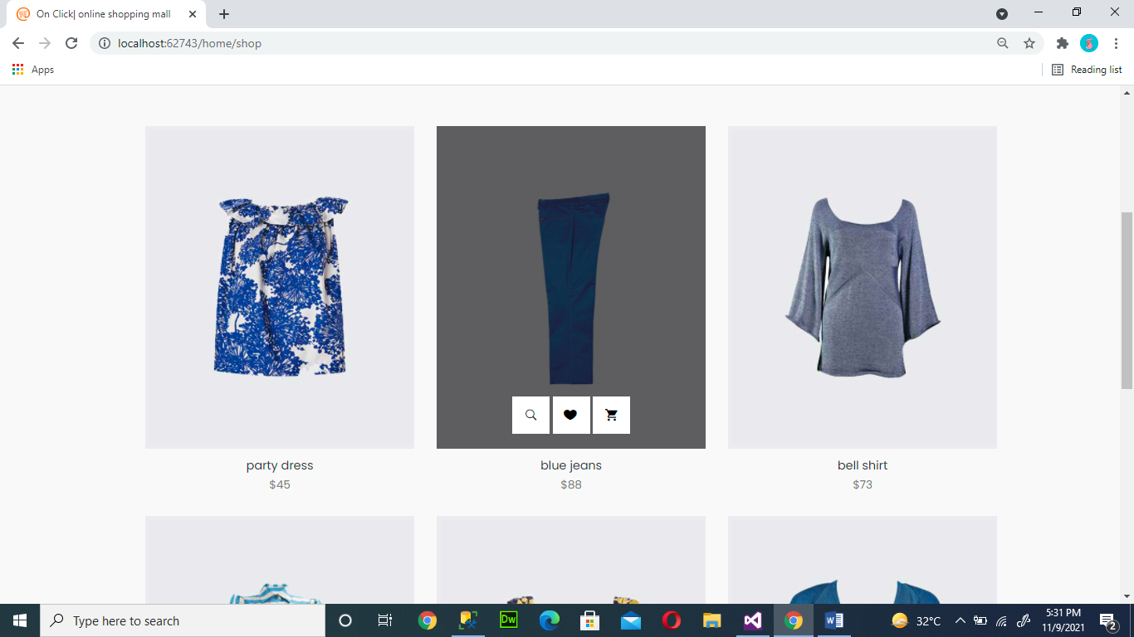

32

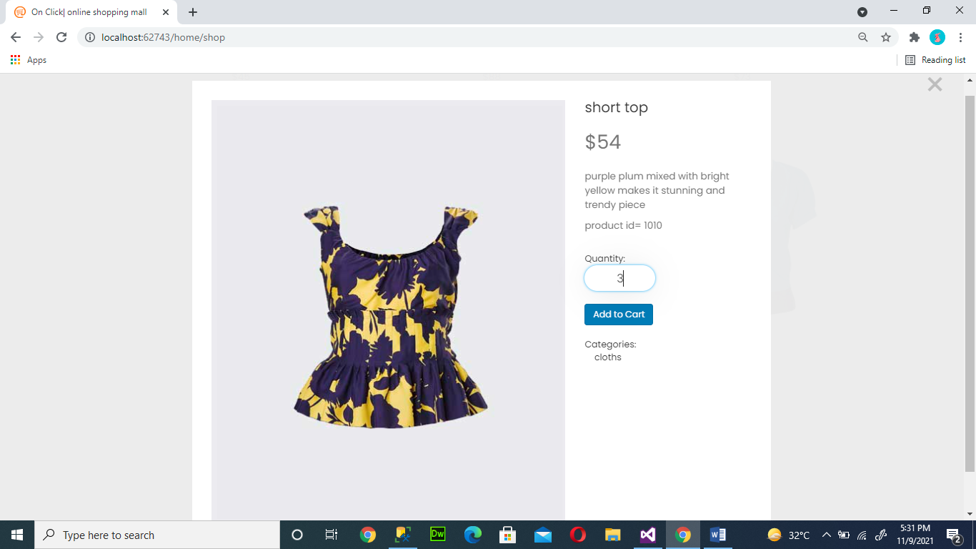

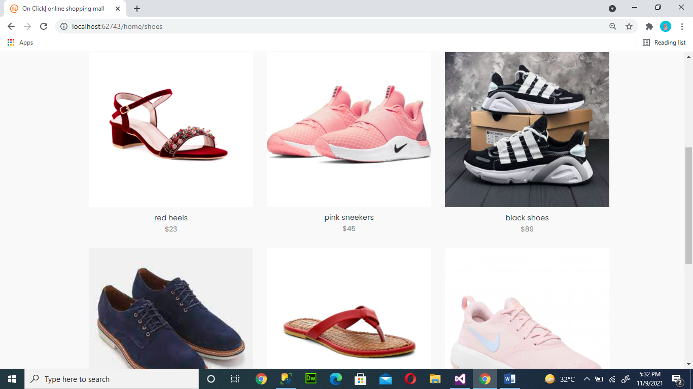

33

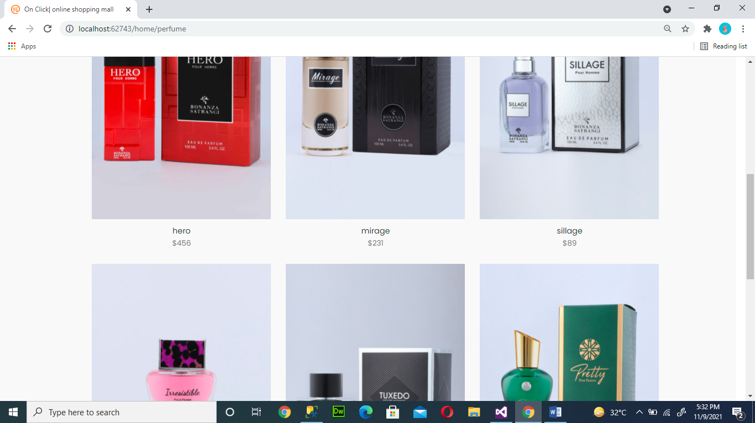

34

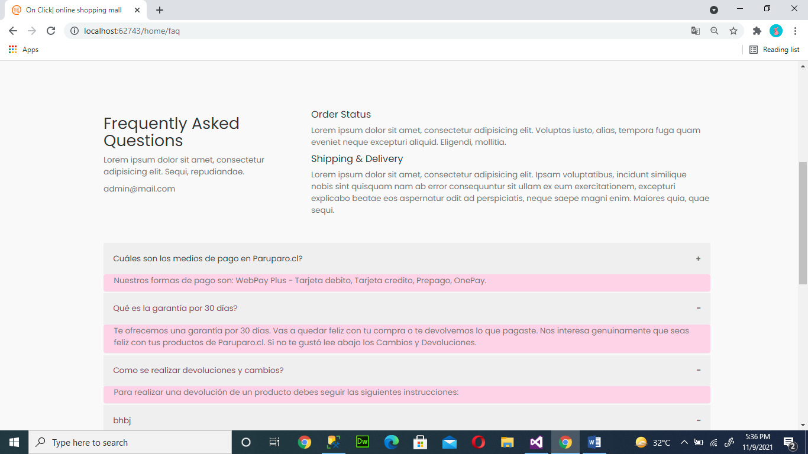

Admin dashboard

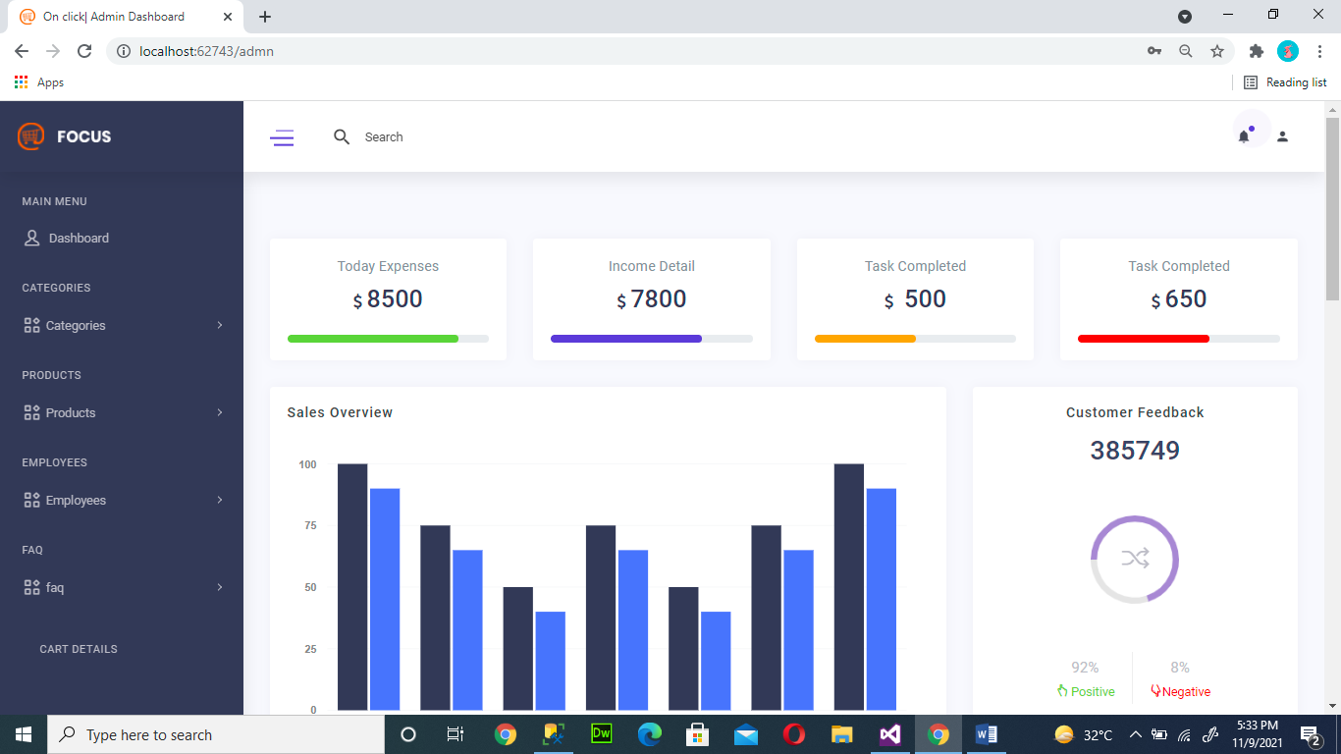

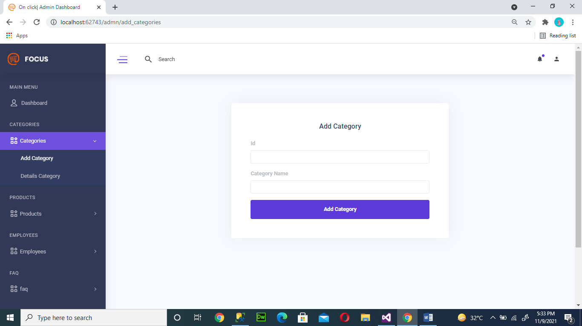

35

